

**A**

**Project Report**

on

**GRIEVANCE REDRESSAL SYSTEM**

submitted as partial fulfillment for the award of

**BACHELOR OF TECHNOLOGY**

**DEGREE**

SESSION 2023-24

in

**Computer Science**

By

Yuvraj Narayan Mishra (2000290120200)

Vishal Yadav (2000290120194)

Shruti Gautam (2000290120155)

**Under the supervision of**

Prof. Pallavi Sharma

Assistant Professor

**Department of Computer Science**

**KIET Group of Institutions, Ghaziabad**

Affiliated to

**Dr. A.P.J. Abdul Kalam Technical University, Lucknow**

**May, 2024**

**DECLARATION**

I/We hereby declare that this submission is our own work and that, to the best of our knowledge and belief, it contains no material previously published or written by another person nor material which to a substantial extent has been accepted for the award of any other degree or diploma of the university or other institute of higher learning, except where due acknowledgment has been made in the text.

Date:

Signature: Signature:

Name: Yuvraj Narayan Mishra Name: Shruti Gautam

2000290120200 2000290120155

Signature:

Name: Vishal Yadav

2000290120194



**CERTIFICATE**

This is to certify that Project Report entitled “**Grievance Redressal System**” which is submitted by “Yuvraj Narayan Mishra, Vishal Yadav and Shruti Gautam” in partial fulfillment of the requirement for the award of degree B. Tech. in Department of Computer Science of Dr. A.P.J. Abdul Kalam Technical University, Lucknow is a record of the candidates own work carried out by them under my supervision. The matter embodied in this report is original and has not been submitted for the award of any other degree.

**Date: Signature of Supervisor**

Prof. Pallavi Sharma

Assistant Professor

**ACKNOWLEDGEMENT**

It gives us a great sense of pleasure to present the report of the B. Tech Project undertaken during B. Tech. Final Year. We owe special debt of gratitude to Professor Pallavi Sharma, Department of Computer Science, KIET, Ghaziabad, for his/her constant support and guidance throughout the course of our work. Her sincerity, thoroughness and perseverance have been a constant source of inspiration for us. It is only his cognizant efforts that our endeavors have seen light of the day.

We also take the opportunity to acknowledge the contribution of Dr. Ajay Kumar Shrivastava, Head of the Department of Computer Science, KIET, Ghaziabad, for his full support and assistance during the development of the project. We also do not like to miss the opportunity to acknowledge the contribution of all the faculty members of the department for their kind assistance and cooperation during the development of our project.

Last but not least, we acknowledge our friends for their contribution in the completion of the project.

Signature:

Name: Yuvraj Mishra Shruti Gautam Vishal Yadav

Roll No.: 2000290120200 2000290120155 2000290120194

|  |  |
| --- | --- |
| **TABLE OF CONTENTS** | **Page**  **No.** |
| DECLARATION………………………………………… | ii |
| CERTIFICATE………………………………………….. | iii |
| ACKNOWLEDGEMENT..……………………………… | iv |
| ABSTRACT……………………………………………… | vii |
| LIST OF FIGURES……………………………………… | viii |
| LIST OF TABLES………………………………………..  LIST OF ABBREVIATIONS……………………………. | ix  x |
|  |  |

**CHAPTER 1 INTRODUCTION**

1.1 Introduction to Project 1

1.2 Project Category 3

1.3 Objectives 3

1.4 Structure of Report 4

**CHAPTER 2 LITERATURE REVIEW**

2.1 Literature Review 7

2.2 Research Gaps 10

2.3 Problem Formulation 10

**CHAPTER 3 PROPOSED SYSTEM**

3.1 Proposed System 13

3.2 Unique Features of the System 14

**CHAPTER 4 REQUIREMENT ANALYSIS AND SYSTEM SPECIFICATION**

4.1 Feasibility Study (Technical, Economical, Operational) 16

4.2 Software Requirement Specification 16

4.2.1 Data Requirement 16

4.2.2 Functional Requirement 17

4.2.3 Performance Requirement 18

4.2.4 Maintainability Requirement 20

4.2.5 Security Requirement 22

4.3 SDLC Model Used 24

4.4 System Design 26

4.4.1 Data Flow Diagrams 27

4.4.2 Workflow Diagram 28

4.5 Database Design 28

**CHAPTER 5 IMPLEMENTATION**

5.1 Introduction Tools and Technologies Used 30

5.2 Dataset Description (if any)

**CHAPTER 6 TESTING, AND MAINTENANCE**

6.1 Testing Techniques and Test Cases Used 31

**CHAPTER 7 RESULTS AND DISCUSSIONS**

7.1 Description of Modules with Snapshots 34

7.2 Key findings of the project 39

7.3 Brief Description of Database with Snapshots 40

**CHAPTER 8 CONCLUSION AND FUTURE SCOPE** 43

REFERENCES (Only in IEEE FORMAT) 45

Research Paper Acceptance Proof 48

Research Paper(If Presented/Published) 50

Proof of patent publication(Screenshot of Publication) 49

**ABSTRACT**

The cornerstone of our initiative lies in the swift identification and resolution of public grievances. We recognize the critical importance of providing citizens with a platform to voice their concerns regarding various local community matters. These issues span a broad spectrum, ranging from sensitive topics such as law and order, sociological challenges like child labor and harassment of women, to practical issues encompassing garbage management, water supply, energy, transportation, and sewage. However, administrative organizations often grapple with the formidable task of managing these complaints effectively. The sheer volume and diversity of grievances demand a systematic approach to categorization and prioritization. To address this challenge, we propose the development of a web application specifically designed to methodically analyze the multitude of complaints received, with the aim of pinpointing common problems and facilitating their resolution. This digital platform will not only streamline the complaint submission process for citizens but also enable administrators to identify trends, allocate resources efficiently, and expedite the resolution of pressing issues. By harnessing the power of technology, we seek to foster greater transparency, accountability, and responsiveness in governance, ultimately enhancing the well-being of our communities.

**LIST OF FIGURES**

**Figure No. Description Page No.**

4.1 DFD Zero level 27

4.2 Workflow Diagram 28

4.3 ER Diagram 29

7.1 User Login Page 34

7.2 Department Member Login Page 35

7.3 Login Page with User Details 35

7.4 Admin Dashboard 36

7.5 User Dashboard 36

7.6 User Registration Page 37

7.7 Complaint Registration Page 37

7.8 Complaint Registration Page Footer 38

7.9 Department Staff/Officer Dashboard 38

7.10 Backend Code for Database Design 40

7.11 Backend Code for User Interface 41

7.12 Database All Tables 41

7.13 Database User Table 42

**LIST OF TABLES**

|  |  |  |
| --- | --- | --- |
| **Table No.** | **Description** | **Page No.** |
| 6.1 | Test Cases Used | 32 |

**LIST OF ABBREVIATIONS**

GRS Grievance Redressal System

CRMS Complaints Resolution Management System

PRS Problem Resolution System

**CHAPTER 1**

**INTRODUCTION**

**1.1 Introduction**

In today's intricate social fabric, grievances are an inevitable aspect of human interactions, stemming from differences, injustices, and internal conflicts. The maintenance of fairness, equity, social cohesion, and institutional trust hinges upon the effective resolution of these grievances. Consequently, governments, organizations, and communities worldwide are increasingly recognizing the imperative of establishing robust grievance redressal mechanisms. A grievance, delineated as an oppressive state resulting from any perceived wrong or hardship endured by an individual, forms the legitimate basis for complaint, demanding remedial action.

Within the framework of any administration, a grievance redressal mechanism constitutes an integral component of the prevailing machinery. The redressal of grievances serves as a litmus test for the efficacy of an organization, underpinning its responsiveness and user-friendliness. Without a well-established system for addressing grievances and complaints, no entity can credibly claim to prioritize the needs and concerns of its constituents. Recognizing this fundamental principle, we embark on an initiative to establish an online grievance redressal system that transcends traditional barriers and empowers both society and Municipal Corporations alike.

Our vision is to harness the power of digital technology to facilitate the resolution of community issues, from cleanliness and environmental concerns to a myriad of other pressing problems. The motivation behind

our endeavor stems from the prevailing reluctance of individuals to engage with bureaucratic processes, often leading to the neglect of vital societal issues. By offering a user-friendly online platform, we aim to bridge the gap between the public and relevant authorities, facilitating seamless communication and efficient problem-solving.

Through the utilization of cutting-edge features such as geo-tagging, our website or app will enable citizens to pinpoint specific issues, providing authorities with direct access to real-time community concerns. This innovative approach not only streamlines the grievance redressal process but also fosters greater accountability and transparency within administrative bodies. In essence, our online grievance redressal system represents more than just a technological solution; it embodies a paradigm shift in governance, where citizen engagement and participatory decision-making lie at the heart of public administration.

Moreover, the imperative for sustainability underscores the urgency of implementing innovative solutions in grievance redressal. Traditional models of complaint resolution often contribute to inefficiencies and disparities, resulting in prolonged grievances and discontent within communities. By promoting an online platform for grievance redressal, the initiative aims to streamline the process and reduce the environmental footprint associated with traditional complaint resolution methods. This includes minimizing the need for physical paperwork, reducing travel requirements for both complainants and administrators, and optimizing resource allocation for more sustainable outcomes.

Finally, the platform recognizes the importance of community empowerment and collaboration in driving effective grievance resolution. By fostering connections among stakeholders, facilitating knowledge exchange, and enabling peer-to-peer support, the platform

cultivates a sense of solidarity and collective action within the community. Through interactive features such as discussion forums, chat rooms, and shared resources, individuals can leverage each other's expertise and experiences to address grievances more effectively. This collaborative approach not only promotes transparency and accountability but also strengthens trust and cohesion within the community, ultimately leading to more equitable outcomes and enhanced community resilience.

**1.2 Project Category**

The technical project category of a “**Revolutionizing Grievance Redressal System: An Adaptive Framework with a Proposed Architecture**” includes various components such as Web-Based Interface, Cloud Hosting, Database Management.

**1.3 Objectives**

* Provide citizens with a convenient and accessible platform to submit grievances from anywhere, at any time.
* Streamline complaint submission, tracking, and resolution processes to expedite grievance resolution.
* Promote transparency by providing users with visibility into the grievance resolution process and updates on grievance status.
* Implement accountability mechanisms to hold responsible parties accountable for their actions or inactions.
* Foster citizen engagement and participation in governance by empowering individuals to voice their concerns and provide feedback.
* Facilitate effective management and analysis of grievance-related data to identify trends and prioritize issues for better resource allocation.
* Enhance trust and confidence in the grievance redressal process by providing a transparent, responsive, and accountable mechanism for addressing citizen grievances.

**1.4 Structure of Report**

**Chapter 1**

The report outlines the development of an online grievance redressal system, highlighting the need for transparent and credible grievance resolution in the digital era. It emphasizes the potential of digital platforms in facilitating efficient resolution of grievances and improving relations between complainants and authorities. The objectives include reducing the cost of grievance resolution, enhancing effectiveness, and fostering improved relations. The report details the project's structure, implementation methodologies, and outcomes, with a focus on achieving transparency and credibility in the authentication of grievance resolution processes.

**Chapter 2**

This chapter deep dives into a comprehensive literature review on web-based equipment sharing platform technology and its applications, focusing on product authentication and traceability. Scholarly papers are reviewed, summarizing key insights into the architecture of web-based grievance redressal systems, the utilization of smart contracts, and frameworks for ensuring affordable access to equipment. Identified research gaps include challenges in interoperability, scalability, and security within grievance resolution platforms. The chapter articulates the problem statement, highlighting the pressing need for innovative solutions to authenticate and maintain quality in grievance resolution processes. Leveraging web-based technology, the project aims to provide timely access to grievance redressal mechanisms, enhancing trust

between users and authorities while ensuring the integrity of the grievance resolution market.

**Chapter 3**

This chapter delineates the envisioned system for web-based grievance redressal, highlighting its innovative features and user-centric approach. Key components include user registration, grievance submission, and a user-friendly interface designed for scalability. The system's distinctive approach aims to provide timely and accessible grievance resolution, setting it apart from traditional methods. Through efficient utilization of web-based technology, the project endeavors to ensure prompt and affordable access to grievance redressal mechanisms, fostering trust and accountability in the resolution process.

**Chapter 4**

This chapter delves into the requirement analysis and system specifications for implementing a web-based application system. It conducts a feasibility study encompassing technical, economic, and operational aspects. The software requirement specification outlines the system's introduction, overall description, assumptions, and dependencies. It details the proposed methodology, operating environment, constraints, external interface requirements, and nonfunctional requirements. Additionally, it discusses the software quality attributes, business rules, and other technical requirements, concluding with the choice of the Agile SDLC model for development. 3 Diagrams, including DFDs and an ER diagram, further elucidate the system's design and functionality.

**Chapter 5**

This chapter introduces the implementation phase, outlining the languages, tools, and technologies employed in developing the web-based authentication system. It highlights the utilization of PHP, JavaScript, HTML, CSS, and MySQL database. This comprehensive

approach aims to ensure robustness and security in grievance redressal process authentication, enhancing confidence and transparency for users.

**Chapter 6**

This chapter focuses on testing and maintenance, detailing various testing techniques and test cases employed. Test cases cover user registration, user login, and complaint registration ensuring the system's functionality, reliability, and security. This meticulous testing process aims to deliver a high-quality and dependable grievance redressal system.

**Chapter 7**

This chapter showcases the results and discussions of the implemented system, presenting user interface representations, module descriptions, snapshots, back-end representations, and database tables. It provides insights into the diverse functionalities and components of the grievance redressal system, elucidating how users submit grievances, authorities authenticate them, and accountability mechanisms ensure resolution integrity. The snapshots offer a visual understanding of the system's interface and backend processes, enhancing comprehension.

**Chapter 8**

This chapter concludes the report by summarizing the research's significance in utilizing web-based grievance redressal system platform, with a focus on meeting consumer needs and fostering trust between complainants and authorities. It outlines future scope, suggesting avenues for improvement such as providing affordable access to grievance resolution mechanisms and implementing effective grievance resolution techniques across all levels.

**CHAPTER 2**

**LITERATURE REVIEW**

**2.1 Literature Review**

[1] This research aims to develop a unified model for e-government adoption in India, validated using data from 419 citizens and nine other models. The proposed model outperforms others, explaining 66% variance in behavioral intentions and showing significant relationships. The study also presents limitations and implications for theory and practice. [2] This paper investigates the factors influencing the adoption of the online public grievance redressal system (OPGRS) in India, based on the government's strategic policy to reform bureaucracy. The model, based on UTAUT, includes constructs like performance expectancy, effort expectancy, social influence, facilitating conditions, self-efficacy, and behavioral intention. The study aims to improve OPGRS's potential for transparency and corruption-free India.

[3] India's states provide online services to empower citizens, addressing issues like corruption and bureaucracy. The Department of Administrative Reforms and Public Grievances (DARPG) addresses grievances from various departments. This paper considers four Indian states and their grievance redressing systems, measuring their performance on a scale. Key metrics include HarSamadhan of Haryana, eSamadhan of Himachal Pradesh, SWAGAT of Gujarat, and JanMitra of Karnataka. [4] This paper examines the success of India's online public grievance redressal system (OPGRS) using an IS success model. It measures intention to use and user satisfaction, finding positive connections between system quality, information quality, perceived usefulness, user satisfaction, and intention to use.

[5] The Grievance Redress System (GRS) is a crucial tool for Bangladesh's public administration. Introduced in 2007, it has evolved into an online system in 2014 to address citizens' grievances. A study assessed the implementation of GRS in district-level government offices, revealing that it is still in its infancy. Service providers were found to be insufficiently following GRS guidelines, with stumbling blocks including complaints submission, institutional incapacity, and lack of monitoring. The study concluded that institutionalizing awareness building programs, service provider capacity development, establishing a separate legal authority, and result-based monitoring are essential for better GRS outcomes. [6] Bitcoin's popularity has led to the development of blockchain, which has been applied across various domains, including the grievance redressal system. This system involves submitting grievances to different hierarchical levels of authority, each with the authority to resolve, revert, and forward them to higher levels. Data integrity is built-in, preventing misuse of power by authorities. The dynamic time threshold transfers grievances to higher authorities, eliminating ignorance and overcoming anomalies in the current grievance system.

[7] Griefs in academic institutions are sensitive and important, especially for students who often fail to express their concerns. Despite a lack of a formulated grievance redressal mechanism in some prestigious colleges of Madhya Pradesh, a prototype has been developed to address these conflicts. This paper focuses on developing and executing this prototype, addressing the identified problem areas and incorporating additional necessary areas to ensure effective grievance redressal for students.

[8] The Grievance Redressal Mechanism (GRM) is crucial in a fast-paced world, especially during the pandemic. It facilitates smooth functioning by receiving complaints and redressing them effectively. With growing technologies and digital literacy, GRMs have become

more accessible, user-friendly, and contactless. This paper reviews existing literature and looks at recent on-field examples of e-governance innovations in states like Kerala, Himachal Pradesh, and Bihar. However, challenges include the ability of GRMs to be accessible to the general public and bridging the digital divide. The paper seeks solutions to these problems for a better future for all.

[9] Grievances arise at any level, especially in education, where students often fail to seek support. A Student Grievance Support System was designed to address these issues. The web application allows students to lodge complaints, which are forwarded to the Grievance Redressal Committee. The committee then forwards the complaints to the appropriate institute or department, ensuring sensitivity. The institute or department takes action and updates the status, providing transparency and enabling students to find solutions. This project aims to improve student experience and satisfaction. [10] This paper examines the success factors of online public grievance redressal systems (OPGRSs) in India, focusing on system quality, information quality, social influence, self-efficacy, perceived trust, user satisfaction, and intention to use. The study aims to improve OPGRS's potential for a transparent, corruption-free country.

[11] In India, citizens expect quality public services, including information technology-enabled versions. To increase citizen satisfaction, countries worldwide aim to develop transparent and accountable online systems. This study aimed to assess the e-service quality of an online grievance redress portal for student users. A survey of 677 respondents was conducted using partial least squares structural equation modeling. Results showed that security and privacy are crucial for student satisfaction, as they build trust in the online e-governance system. Reliability and quality of information delivery were also important. Gender did not significantly affect student satisfaction with e-

government services. The study's limitations and future research scope are also presented.

* 1. **Research Gaps**
* Limited research on how different user demographics (e.g., age, digital literacy, disability) interact with online grievance systems.
* Lack of standardized metrics to measure the effectiveness and efficiency of online grievance redressal systems.
* Insufficient studies on the integration of online grievance redressal systems with other organizational processes and technologies (e.g., CRM, ERP).
* Limited research on the privacy and security concerns specific to online grievance redressal systems, especially in the context of sensitive data handling.
* Scarcity of studies on how cultural and contextual factors influence the design and effectiveness of grievance redressal systems across different regions.
* Limited understanding of how online grievance redressal systems impact organizational culture and employee behavior over time.
* Need for more research on the application of emerging technologies (e.g., AI, machine learning, blockchain) in enhancing online grievance redressal systems.
* Insufficient research on the psychological and behavioral aspects influencing how individuals file grievances and interact with the system.

**2.3 Problem Formulation**

The problem formulation of the online grievance redressal system project delves into the multifaceted challenges entrenched within traditional grievance resolution mechanisms. These challenges stem

from systemic inefficiencies and procedural bottlenecks that impede the timely and effective resolution of citizen grievances. At the forefront is the issue of limited accessibility, wherein citizens face hurdles in navigating bureaucratic processes to submit their grievances. Cumbersome paperwork, convoluted submission procedures, and restrictive operating hours of grievance redressal offices often deter individuals from seeking recourse for their concerns.

Moreover, the protracted response times characteristic of traditional grievance resolution exacerbate the frustrations of citizens, leaving them disillusioned with the efficacy of administrative mechanisms. Lengthy delays in processing grievances not only exacerbate the underlying issues but also erode public trust in the responsiveness of government institutions. This lack of timely intervention perpetuates a cycle of discontent and disengagement among the populace, further undermining the legitimacy of governance structures.

Transparency and accountability deficits represent another critical aspect of the problem formulation. The opacity surrounding the grievance resolution process breeds mistrust and skepticism among citizens, who are left in the dark regarding the status and outcome of their complaints. Without clear channels for communication and feedback, individuals feel marginalized and disenfranchised, fostering a sense of alienation from the decision-making processes that directly impact their lives.

Furthermore, the absence of robust accountability mechanisms within traditional grievance redressal systems exacerbates these challenges. Without adequate oversight and enforcement mechanisms, authorities may neglect or mishandle grievances with impunity, leading to a breakdown in the social contract between citizens and their representatives. This lack of accountability not only undermines the legitimacy of administrative bodies but also perpetuates a culture of impunity that undermines the rule of law.

In light of these entrenched challenges, the project endeavors to develop an online grievance redressal system that addresses these systemic shortcomings comprehensively. By leveraging digital technologies and user-centric design principles, the system aims to enhance accessibility, streamline the resolution process, ensure transparency, and foster accountability. Through these interventions, the project seeks to empower citizens, restore trust in public institutions, and promote a culture of responsive and accountable governance.

**CHAPTER 3**

**PROPOSED SYSTEM**

**3.1 Proposed System**

“Grievance Redressal System” project envisions a comprehensive and user-centric platform designed to address the myriad challenges inherent in traditional grievance resolution mechanisms. At its core, the system will offer a seamless and accessible interface, empowering citizens to submit grievances easily from anywhere, at any time. Through intuitive design and user-friendly features, individuals will navigate the process with ease, eliminating barriers to participation and ensuring inclusivity across diverse demographics. The system will prioritize efficiency by streamlining the grievance resolution process, leveraging automation and real-time tracking mechanisms to expedite responses and minimize delays. Transparency will be a cornerstone of the system, with clear channels for communication and feedback enabling users to monitor the progress of their complaints and access information regarding resolution outcomes. Moreover, robust accountability measures will be integrated to hold responsible parties answerable for their actions, thereby fostering trust and confidence in the integrity of the grievance redressal process. Leveraging advanced technologies such as data analytics and machine learning, the system will continuously evolve to meet the evolving needs of users and adapt to emerging challenges. By harnessing the power of digital innovation, the proposed system aims to revolutionize grievance redressal, promoting citizen empowerment, enhancing institutional responsiveness, and ultimately fostering a more equitable and accountable society.

**3.2 Unique Features of the System**

**1. Scalability and Flexibility:** Leveraging cloud infrastructure, the system offers unparalleled scalability, allowing it to seamlessly accommodate varying volumes of grievances without compromising performance. This scalability ensures that the system remains responsive and accessible, even during peak demand periods.

**2. Geo-Tagging for Location-Specific Grievances:** A unique feature of the system is its integration of geo-tagging capabilities, enabling users to pinpoint the location of their grievances with precision. This functionality facilitates the prompt identification and resolution of location-specific issues, such as infrastructure problems or service disruptions.

**3. User-Centric Interface:** The system prioritizes user experience, offering an intuitive and user-friendly interface that simplifies the grievance submission process. By minimizing complexity and reducing barriers to entry, the platform empowers individuals to voice their concerns effortlessly.

**4. Real-Time Tracking:** A key distinguishing feature is the incorporation of real-time tracking mechanisms, allowing users to monitor the status of their grievances at every stage of the resolution process. This transparency fosters trust and confidence in the system's responsiveness and accountability.

**5. Integrated Feedback Mechanism:** The platform features an integrated feedback mechanism that solicits user input on their experience with the grievance resolution process. By collecting feedback and evaluating user satisfaction, the system continuously iterates and improves its functionality to better serve the needs of stakeholders.

**6. Automated Escalation:** To expedite resolution and ensure timely intervention, the system utilizes automated escalation protocols that

escalate unresolved grievances to higher authorities based on predefined criteria. This proactive approach minimizes bottlenecks and ensures swift action on critical issues.

**CHAPTER 4**

**REQUIREMENT ANALYSIS AND SYSTEM SPECIFICATION**

**4.1 Feasibility Study**

* **Technical Feasibility:**
* Availability of expertise and resources.
* Infrastructure requirements and scalability.
* Compatibility and integration with existing systems.
* **Operational Feasibility:**
* User acceptance and ease of use.
* Scalability to accommodate growth.
* Operational efficiency and streamlining processes.
* **Economic Feasibility:**
* Cost-benefit analysis.
* Revenue streams and ROI.
* Potential for cost savings for users.
* **Legal and Regulatory:**
* Compliance with data privacy and financial regulations.
* Addressing intellectual property rights.

**4.2 Software Requirement Specification**

**4.2.1 Data Requirements:**

**4.2.1.1 User Profiles:**

The system needs to store comprehensive user profiles containing relevant information about each user. This includes usernames, passwords (stored securely using encryption techniques), contact details such as phone numbers and email addresses.

**4.2.1.2 Database Data:**

Database data refers to the structured information stored within a database management system (DBMS) that is organized and accessible for efficient retrieval and manipulation. It encompasses various types of data, such as text, numbers, dates, and multimedia files, all stored in a structured manner within tables, rows, and columns. Database data plays a vital role in modern businesses and organizations, serving as a foundation for decision-making, analysis, and day-to-day operations.

**4.2.1.3 Activity Logs:**

To keep track of user interactions and maintain a record of changes made to the system's content, activity logs are necessary. These logs capture the actions performed by users, such as editing or updating saved data, and also record contributions made by users. By maintaining activity logs, it becomes easier to track changes, review user contributions, and provide a history of interactions within the system.

* + 1. **Functional Requirements:**

**4.2.2.1 User Registration and Authentication:**

The application should allow users to create accounts by providing necessary details such as username, password, email, aadhar number and contact number.

Users should be able to authenticate themselves securely using their credentials to access their accounts.

**4.2.2.2 User Profile Management:**

Users should have the capability to create and maintain their profiles within the grievance redressal system. The platform should enable users to input and modify their personal details, including contact information, email addresses, and location. Additionally, users should have the option to provide details about their grievances, such as the nature of the issue,

relevant parties involved, and any supporting documentation. The system can offer templates or guidance to assist users in crafting comprehensive profiles. Moreover, users should be able to update their grievance history, allowing for a comprehensive overview of past concerns and resolutions.

**4.2.2.3 Security and Data Privacy:**

The application should implement appropriate security measures to protect user data, including encryption of sensitive information and secure storage of user credentials.

The application should comply with relevant data protection regulations to ensure user privacy and consent.

**4.2.3 Performance Requirements:**

**4.2.3.1 Responsiveness:**

The application should respond quickly to user interactions, such as navigating between profile page, add complaint page, etc.

The response time for each action should be within milliseconds to provide a smooth and seamless user experience.

**4.2.3.2 Loading Time:**

The application should load quickly, particularly when users access their profile, records and submit grievances.

It is essential that the initial loading time is kept to a minimum to enable users to promptly initiate the grievance resolution process without experiencing significant delays.

**4.2.3.3 Scalability:**

The application should be able to handle a growing number of users and profiles without significant degradation in performance. As the user base expands, the application should scale horizontally by adding additional resources or utilizing cloud-based infrastructure.

**4.2.3.4 Concurrent Users:**

The application should be capable of supporting multiple concurrent users without experiencing performance issues or slowdowns.

It should handle simultaneous requests from different users effectively and maintain responsiveness throughout.

**4.2.3.5 File Size and Storage:**

Profile and related files should be stored efficiently to minimize storage requirements and optimize performance.

The application should handle files of various sizes, from small profiles to larger multimedia, without impacting performance during file uploads or downloads.

**4.2.3.6 Caching and Optimization:**

Implement caching mechanisms to store frequently accessed data, such as user preferences, to reduce database queries and improve response times.Optimize database queries, API calls, and resource utilization to ensure efficient use of system resources and reduce response times.

**4.2.3.7 Integration Performance:**

If the application integrates with external systems, such as users records or grievance data, ensure that data retrieval and synchronization processes are efficient.

Minimize delays and errors during data transfers to provide a seamless user experience and maintain data consistency.

**4.2.3.8 Error Handling:**

The application should handle errors gracefully, providing meaningful error messages and recovering from failures without compromising overall performance.

Error handling mechanisms should be in place to identify and resolve issues quickly to minimize downtime and maintain the application's performance.

**4.2.3.9 Performance Monitoring:**

Implement performance monitoring tools to track system performance, identify bottlenecks, and proactively address any performance related issues. Continuously monitor response times, server load, database performance, and other relevant metrics to ensure optimal application performance.

**4.2.4 Maintainability Requirements:**

**4.2.4.1 Modularity and Component-based Architecture:**

The application should be designed with a modular architecture that allows for independent development and maintenance of different components.

Use component-based design patterns to ensure that individual modules can be updated or replaced without impacting the overall functionality of the application.

**4.2.4.2 Code Readability and Documentation:**

Ensure that the application code follows consistent coding conventions and is well-documented to enhance readability and ease of maintenance.

Document the purpose, functionality, and dependencies of each module or component to assist developers in understanding and maintaining the code base.

**4.2.4.3 Separation of Concerns:**

Apply the principle of separation of concerns to ensure that different parts of the application have well-defined responsibilities and are decoupled from each other.

This promotes code maintainability by making it easier to isolate and fix issues or add new features without affecting unrelated parts of the application.

**4.2.4.4 Version Control and Source Code Management:**

Utilize a version control system, such as Git, to manage the source code repository effectively. Enforce best practices for branching, merging, and commit messages to ensure traceability and facilitate collaboration among developers.

Maintain a clear release management process to manage different versions of the application and track changes over time.

**4.2.4.5 Automated Testing and Test Coverage:**

Implement a comprehensive suite of automated tests to validate the functionality of the application and ensure that changes or updates do not introduce regressions.

Aim for high test coverage to minimize the risk of undiscovered bugs and facilitate efficient maintenance by quickly identifying affected areas when modifications are made.

**4.2.4.6 Error Logging and Monitoring:**

Implement robust error logging mechanisms to capture and record errors that occur during application usage.

Monitor and analyze error logs to identify recurring issues or patterns and proactively address them to improve the stability and maintainability of the application.

**4.2.4.7 Dependency Management:**

Manage external dependencies effectively by using package managers and dependency resolution tools.

Regularly update dependencies to leverage bug fixes, security patches, and new features provided by the dependency providers.

**4.2.4.8 Documentation and Knowledge Base:**

Maintain comprehensive documentation that describes the architecture, design decisions, deployment procedures, and configuration details of

the application. Establish a knowledge base or wiki to document common issues, troubleshooting steps, and solutions to facilitate efficient maintenance and support.

**4.2.4.9 Continuous Integration and Deployment:**

Implement a CI/CD (Continuous Integration/Continuous Deployment) pipeline to automate the build, test, and deployment processes. This helps ensure that changes are thoroughly tested before being deployed, reducing the risk of introducing issues into the production environment.

**4.2.4.10 Regular Code Reviews and Refactoring:**

Conduct regular code reviews to identify areas for improvement, code smells, and potential performance bottlenecks. Encourage refactoring of code to enhance maintainability, readability, and adherence to best practices.

* + 1. **Security Requirements:**

**4.2.5.1 User Authentication and Authorization:**

Implement a secure user authentication mechanism, such as password-based authentication or multi-factor authentication, to ensure that only authorized users can access the application.

Enforce strong password policies, including requirements for complexity and regular password updates, to protect user accounts from unauthorized access.

**4.2.5.2 Secure Data Storage:**

Store sensitive user information, such as usernames, passwords, aadhar number, email and contact details, in a secure manner.

Utilize encryption techniques, such as hashing and salting, to protect stored passwords from unauthorized disclosure.

Employ secure database configurations and access controls to prevent unauthorized access to user data.

**4.2.5.3 Secure Communication:**

Encrypt all communication between the client and the server using secure protocols, such as HTTPS, to prevent eavesdropping and data tampering.

Implement secure coding practices to prevent common web application vulnerabilities, such as cross-site scripting (XSS) and SQL injection attacks.

**4.2.5.4 Role-Based Access Control:**

Implement role-based access control (RBAC) to ensure that users have appropriate access privileges based on their roles and responsibilities.

Restrict access to sensitive functionality or data based on user roles to prevent unauthorized actions or data exposure.

**4.2.5.5 Data Privacy and Protection:**

Comply with data protection regulations, such as GDPR (General Data Protection Regulation) or CCPA (California Consumer Privacy Act), to ensure the privacy and protection of user data. Obtain user consent when collecting personal information and provide clear and transparent information on how user data is processed, stored, and shared.

**4.2.5.6 Secure File Handling:**

Implement secure file upload and download mechanisms to prevent the uploading or downloading of malicious files. Validate file types, sizes, and content to ensure that only safe and authorized files are processed by the application.

**4.2.5.7 Regular Security Updates:**

Stay updated with the latest security patches and updates for all software components, frameworks, libraries, and dependencies used in the application. Monitor security advisories and promptly apply patches to address identified vulnerabilities and ensure a secure environment.

**4.2.5.8 Session Management:**

Implement secure session management techniques, such as session timeouts and secure session storage, to mitigate the risk of session hijacking or session fixation attacks.

Enforce proper session invalidation and logout mechanisms to ensure that user sessions are terminated securely.

**4.2.5.9 Secure Third-Party Integrations:**

Evaluate the security practices and reputation of third-party services or APIs used in the application. Implement secure integration patterns and protocols when interacting with external services to protect against data breaches or unauthorized access.

**4.2.5.10 Security Testing and Auditing:**

Conduct regular security testing, including vulnerability scanning, penetration testing, and code reviews, to identify and address security vulnerabilities. Perform security audits to assess the overall security posture of the application and validate compliance with security standards and best practices.

**4.3 SDLC Model Used**

**Agile Model:**

The Agile Software Development Life Cycle (SDLC) model is an iterative and incremental approach to software development that emphasizes flexibility, collaboration, and responsiveness to change. Unlike traditional waterfall models, where development progresses through sequential stages with fixed requirements, Agile promotes adaptive planning, iterative development, and continuous improvement throughout the project lifecycle.

**Flexibility:** Agile methodology is essential for an online grievance redressal system project, as user needs and external circumstances may evolve over time. Just as in any domain, external factors such as societal changes, legal developments, and technological advancements can influence the nature and volume of grievances received. By adopting Agile principles, the project can promptly respond to these fluctuations, ensuring the system remains adaptable and effective in addressing citizen concerns. This flexibility enables iterative improvements and adjustments, aligning the grievance redressal system with the dynamic landscape of user requirements and external influences.

**Iterative Development:** Agile emphasizes iterative development, enabling the project team to deliver functionality incrementally and receive feedback from stakeholders at regular intervals. This iterative approach aligns well with the goal of developing a platform that meets the specific needs of peoples, allowing for adjustments based on user feedback.

**Continuous Improvement:** Agile promotes continuous improvement through ongoing collaboration between developers, stakeholders, and end-users. This collaborative approach fosters innovation, problem-solving, and adaptation to changing circumstances, which are essential for the success of a project aimed at revolutionizing grievance redressal management.

**Stakeholder Involvement:** Agile methodology promotes the active engagement of stakeholders throughout the development process, ensuring their needs and preferences are prioritized. In the context of an online grievance redressal system, involving various stakeholders, such as citizens, government officials, and legal experts, can help guarantee that the platform effectively addresses their concerns and enhances the efficiency and transparency of the grievance resolution process.

This collaborative approach fosters a sense of ownership and accountability among stakeholders, leading to the development of a more robust and user-centric grievance redressal system.

**4.4 System Design**

**User Interface Design:**

The application should have an intuitive and user-friendly interface, with clear navigation and well-organized sections. The design should be responsive, ensuring compatibility with various devices and screen sizes. The user interface should provide visually appealing interactive interface, customizable formatting options, and real-time previews to enhance the user experience.

**Database Design:**

The application should utilize a robust database management system to store and manage user data. This includes storing user profiles in a dedicated table, with fields such as username, encrypted password, contact details, email, and other relevant profile information.

Additionally, activity logs should be stored in a separate table, capturing user interactions, changes to grievances, and timestamps for tracking purposes. This structured approach ensures the security and integrity of user data while facilitating effective management of grievance resolution processes.

**Authentication and Security:**

User authentication should be implemented using secure mechanisms, such as password hashing and salting. The application should enforce password complexity rules and provide secure password recovery options. Role-based access control can be implemented to manage user permissions and restrict access to sensitive features or data.

**Profile Management:**

Users should be empowered to create, update, and delete their profiles and grievance details, including relevant information such as contact details and the nature of their grievances. Validation checks should be implemented to verify the accuracy and completeness of user input, enhancing data quality and reliability. Additionally, the application should offer tools for organizing and customizing grievance submissions, allowing users to arrange sections, add new sections, and reorder existing sections as needed for a streamlined resolution process.

**4.4.1** **Data Flow Diagram**

**DFD Level - 0:**

A zero level DFD, also known as a context diagram, is a simple model that aids in the identification and definition of the interfaces and boundaries between the external world and the proposed system. It can be used to identify entities that interact with the proposed system but are not part of it.

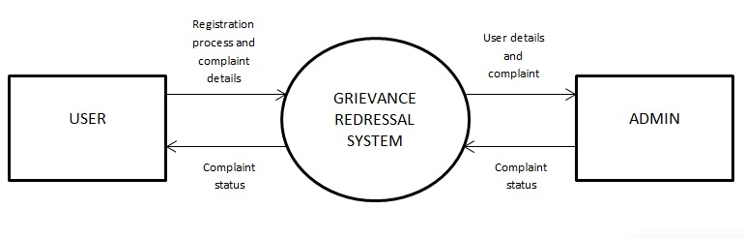

Figure 4.1 DFD Zero Level

* + 1. **Workflow Diagram**

A workflow diagram is a visual representation of the steps involved in completing a process. It uses nodes to represent tasks, arrows to show the flow of work between tasks, decision points for branching paths, and start and end points to mark the beginning and completion of the process. Workflow diagrams help visualize and analyze processes, identify inefficiencies, and streamline operations.

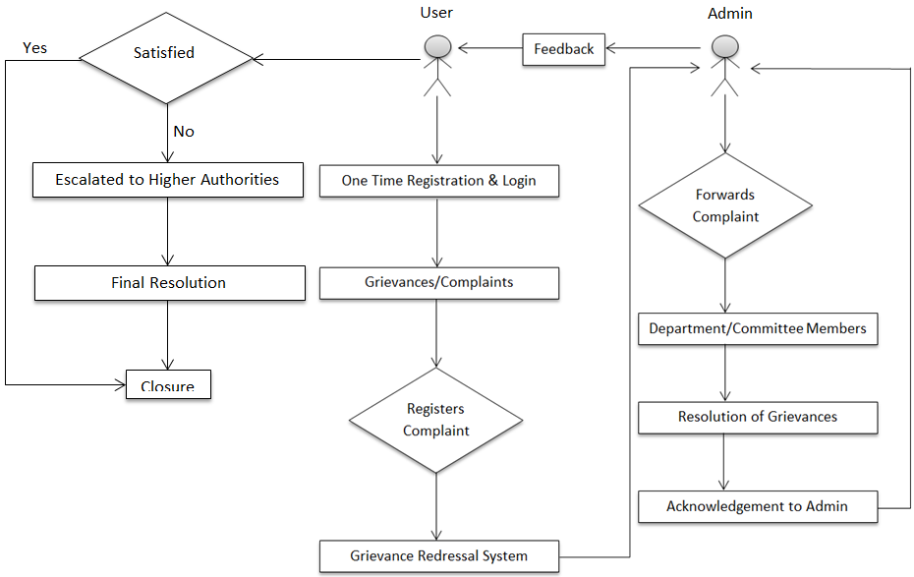

Figure 4.2 Workflow Diagram

**4.5 Database Design**

The database design for the online grievance redressal system encompasses distinct tables to effectively manage user, admin, and department officer data. The central table is the "Users" table, containing fields such as username, encrypted password, contact details, and email. This table serves as the primary repository for user profiles, enabling users to create, update, and delete their accounts. Additionally, an

"Admins" table is established to store administrative credentials, including username and encrypted password, granting access to system management functionalities. For department officers, a dedicated "Officers" table is utilized, housing information such as officer name, department affiliation, and contact details. Relationships between these tables are established through foreign key constraints, allowing for seamless integration and data integrity. Access control mechanisms are implemented to regulate user privileges, ensuring that only authorized individuals can perform specific actions within the system. Overall, this database design provides a structured framework for managing user, admin, and department officer data, facilitating efficient operation and administration of the online grievance redressal system.

**4.5.1 Entity Relationship Diagram**

An entity relationship diagram (ERD) shows the relationships of entity sets stored in a database. An entity in this context is a component of data. In other words, ER diagrams illustrate the logical structure of databases.

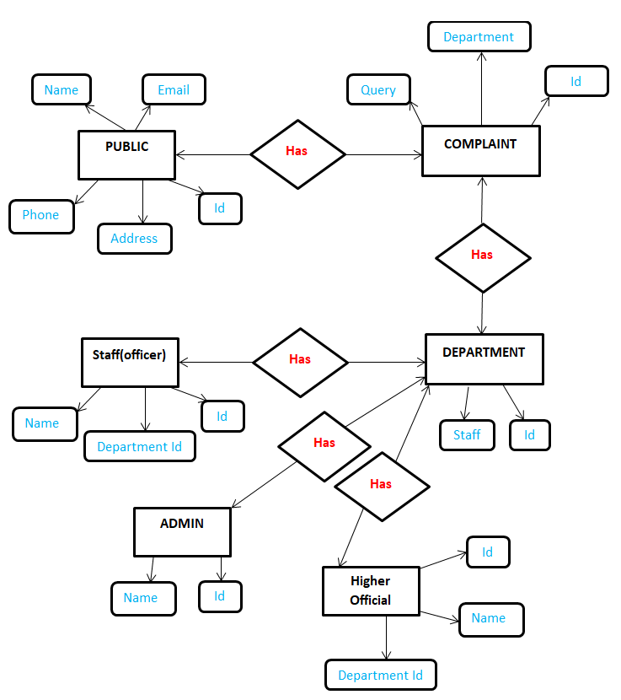

Figure 4.3 Entity Relationship Diagram

**CHAPTER 5**

**IMPLEMENTATION**

**5.1 Introduction Tools and Technologies Used**

Developing a social media platform for developers requires the use of various languages, tools, and technologies to ensure efficient and robust implementation. Here's an introduction to some of the commonly used technologies in this context:

Programming Languages:

Backend Development: PHP (Hypertext Preprocessor), or Node.js are often used for server-side development, handling data processing, and implementing the core functionalities of the platform.

Frontend Development: HTML, CSS, and JavaScript are essential for building the user interface (UI) and enabling interactive features on the client-side.

Frontend Frameworks: Popular choices include React, Angular, or Vue.js, which offer efficient UI component management, state management, and data binding for building dynamic and responsive user interfaces.

Database Management Systems (DBMS):

* Relational Databases: MySQL, are commonly used for structured data storage, providing features like querying, indexing, and ensuring data integrity.
* Version Control: Git, a widely used version control system, allows developers to track and manage code changes, collaborate effectively, and maintain a history of the project's development.

**CHAPTER 6**

**TESTING AND MAINTENANCE**

**6.1 Testing Techniques and Test Cases Used**

Testing techniques and test cases play a crucial role in ensuring the quality and reliability of a resume building platform for developers. Here are some common testing techniques and test cases used in this context:

**6.1.1 TEST LEVELS**

1**. Unit Testing:**

What: Testing individual units or components of the system in isolation.

How: Developers write tests for each function, method, or class.

Tools: Unit testing frameworks such as JUnit, NUnit, pytest.

2**. Integration Testing:**

What: Testing interactions between integrated units/modules.

How: Ensuring that units work together as expected.

Tools: Integration testing frameworks like TestNG, JUnit, Postman.

3. **System Testing:**

What: Testing the entire system as a whole.

How: Verifying all components work together in the intended environment.

Tools: Automated testing tools, custom scripts.

4. **Acceptance Testing:**

What: Ensuring the system meets user requirements and specifications.

How: Typically involves end-users or stakeholders.

Tools: User acceptance testing (UAT) frameworks, Selenium, Cucumber.

**6.1.2 Test Cases Used:**

**Table No. 6.1 – Test cases used**

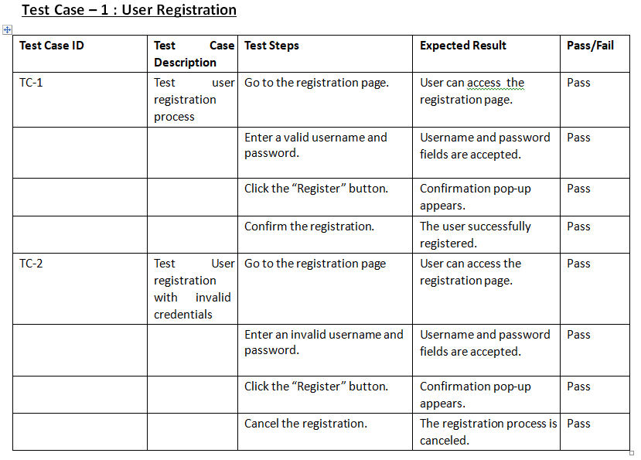

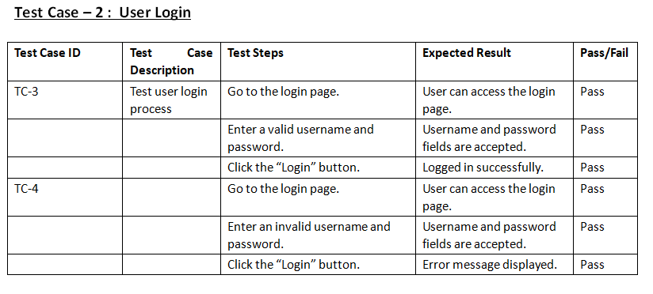

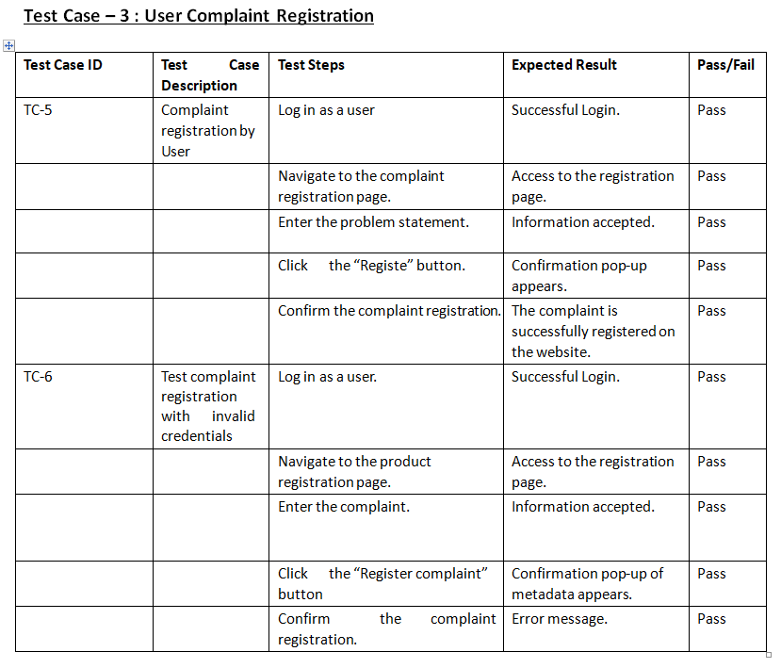

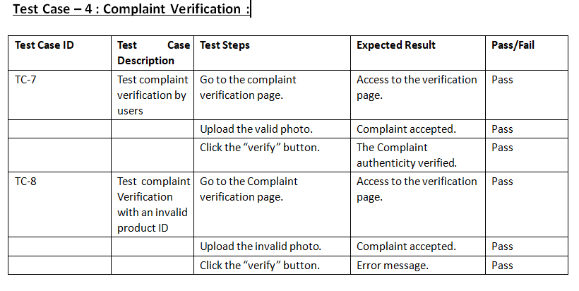

**CHAPTER 7**

**RESULTS AND DISCUSSIONS**

* 1. **Description Of Modules With Snapshots**

**The following figure shows the landing page of our website:**

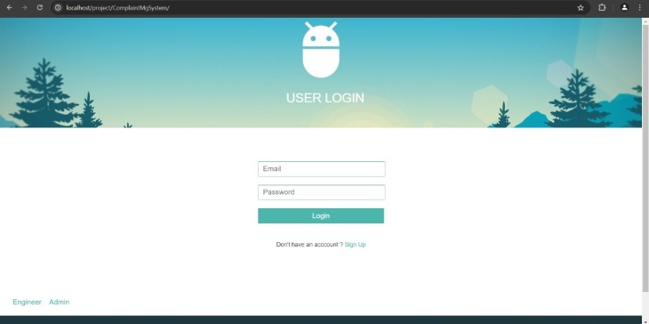

**Figure 7.1** **User Login Page**

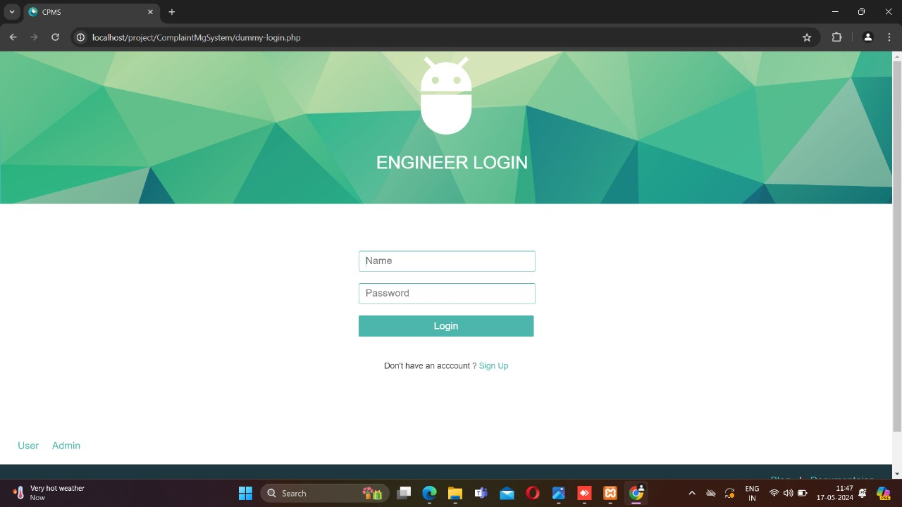

**Figure 7.2 Department Member Login Page**

**The following image shows details that user has provided :**

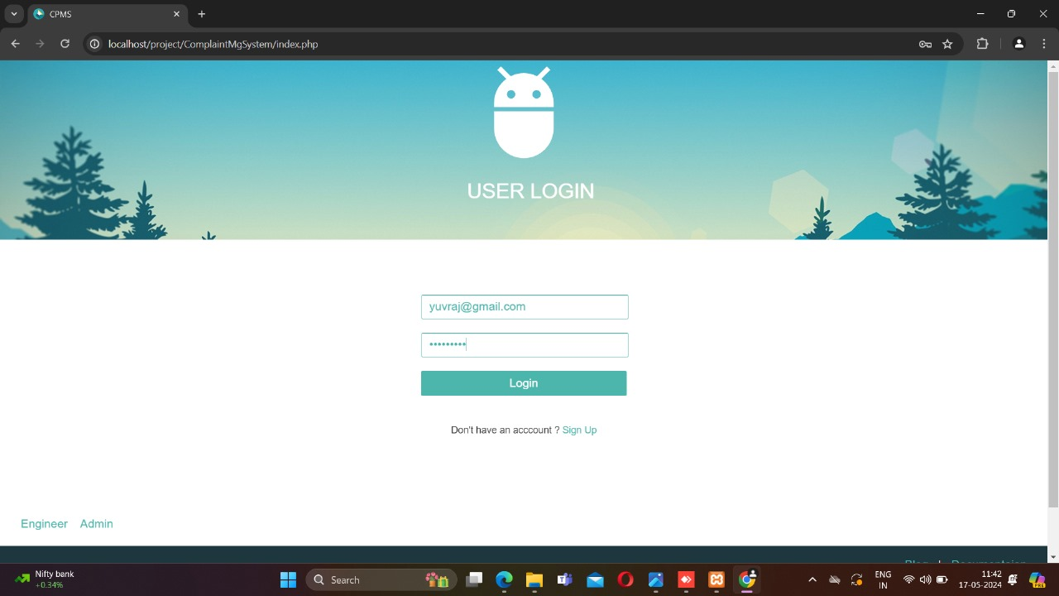

**Figure 7.3 Login Page with User Details**

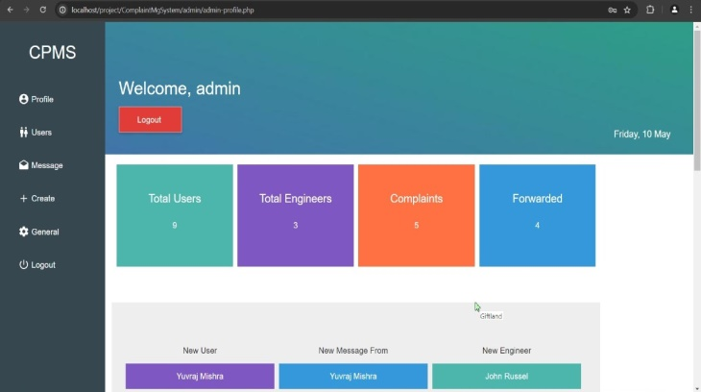

**Figure 7.4 Admin Dashboard**

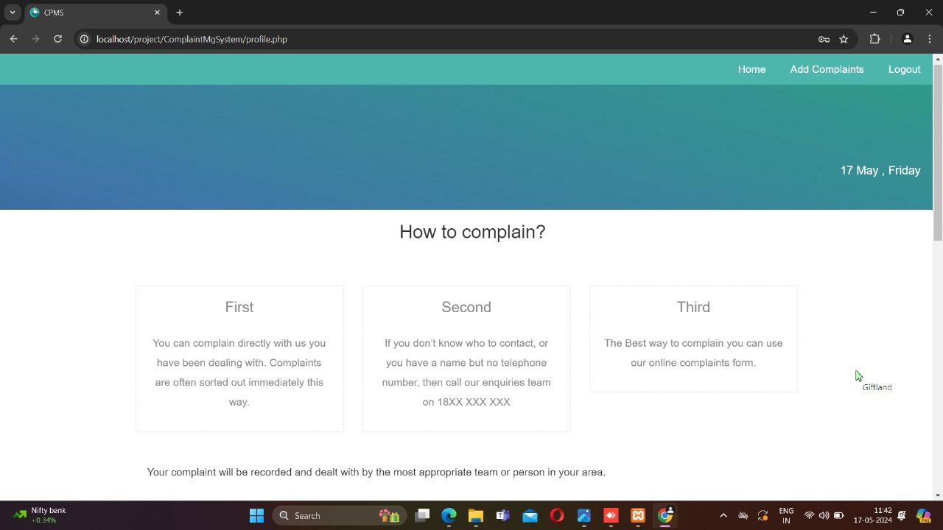

**Figure 7.5 User Dashboard**

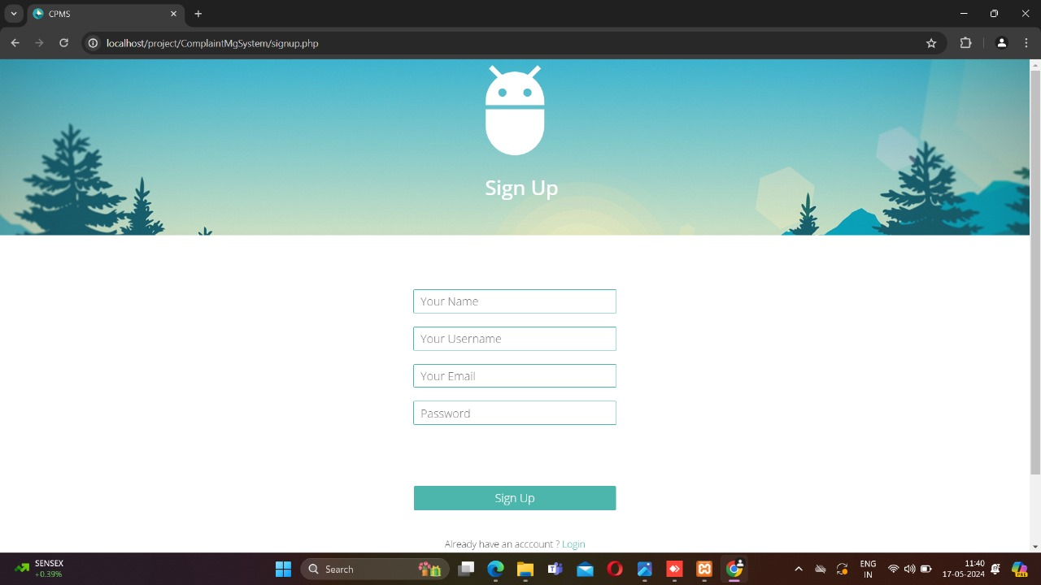

**Figure 7.6 User Registration Page**

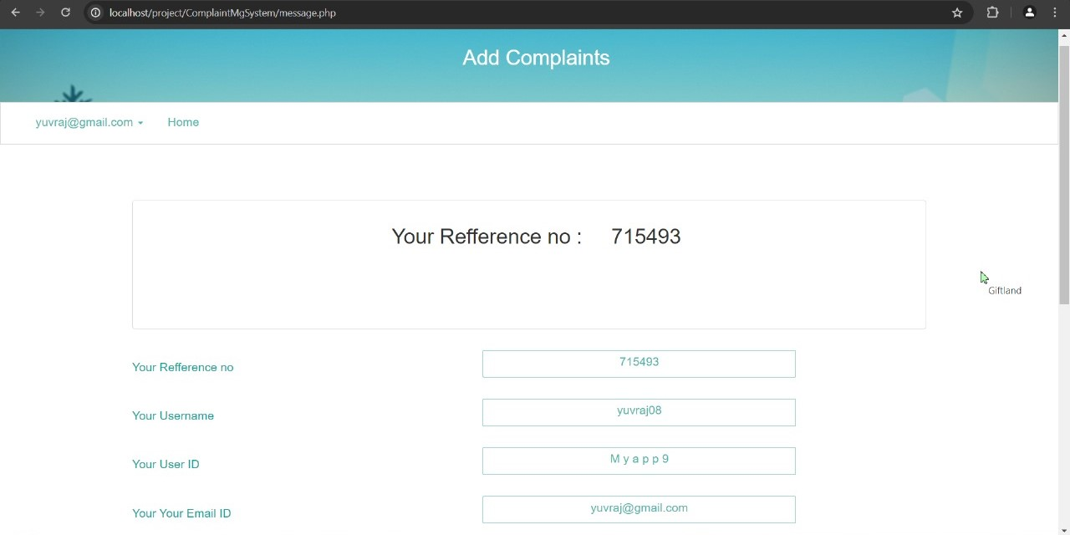

**Figure 7.7 Complaint Registration Page**

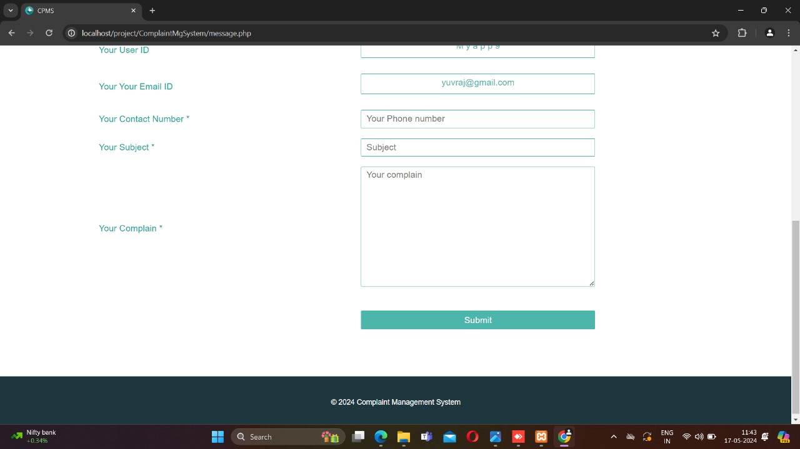

**Figure 7.8 Complaint Registration Page Footer**

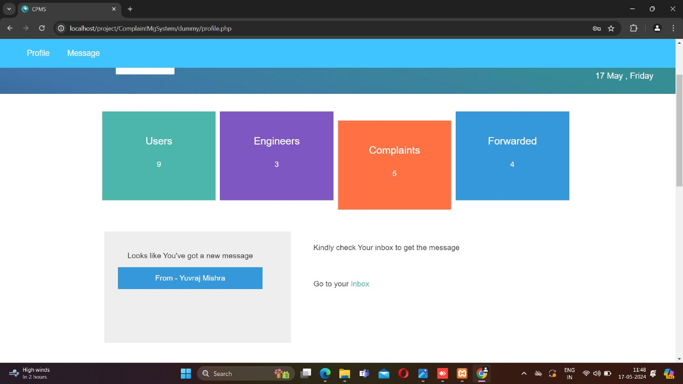

**Figure 7.9 Department Staff/Officer Dashboard**

**7.2 Key Findings of the Project**

1. **Improved Customer Satisfaction**: Effective grievance redressal system lead to higher levels of customer satisfaction as they provide a structured method for addressing complaints, ensuring that customers feel heard and valued.
2. **Increased Trust and Transparency**: Transparent grievance handling processes enhance trust between the organization and its stakeholders. Clear communication about how grievances are managed helps build credibility and trust.
3. **Enhanced Organizational Efficiency**: Streamlined grievance processes reduce the time and resources spent on dispute resolution, allowing organizations to operate more efficiently. Automation and digital tools further enhance this efficiency.
4. **Identification of Systemic Issues**: Regular analysis of grievances can highlight recurring problems or systemic issues within the organization, providing valuable insights for process improvement and risk management.
5. **Customer and Employee Empowerment**: Providing a platform for grievances empowers customers and employees by giving them a voice and ensuring their issues are acknowledged and resolved.
6. **Employee Morale and Retention**: In workplaces, an effective grievance system ensures that employee concerns are addressed promptly and fairly, leading to higher morale, job satisfaction, and retention rates.
7. **Conflict Reduction**: Properly managed grievance systems help reduce conflicts by addressing issues before they escalate, fostering a more harmonious environment.
8. **Continuous Improvement**: Feedback from grievances often leads to continuous improvement initiatives within the organization, contributing to better products, services, and work environments.

**7.3 Brief Description of Database with Snapshots**

The back-end representation of a social media platform for developers involves the implementation of various components and technologies that handle the server-side operations and data management.

* + 1. **Snapshot of Backend Code**

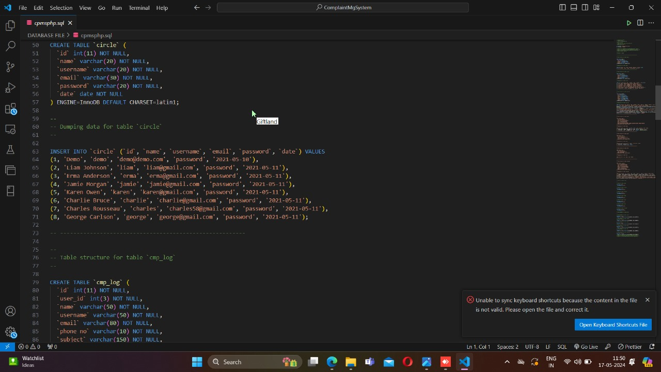

**Figure 7.10 Backend code for Database Design**

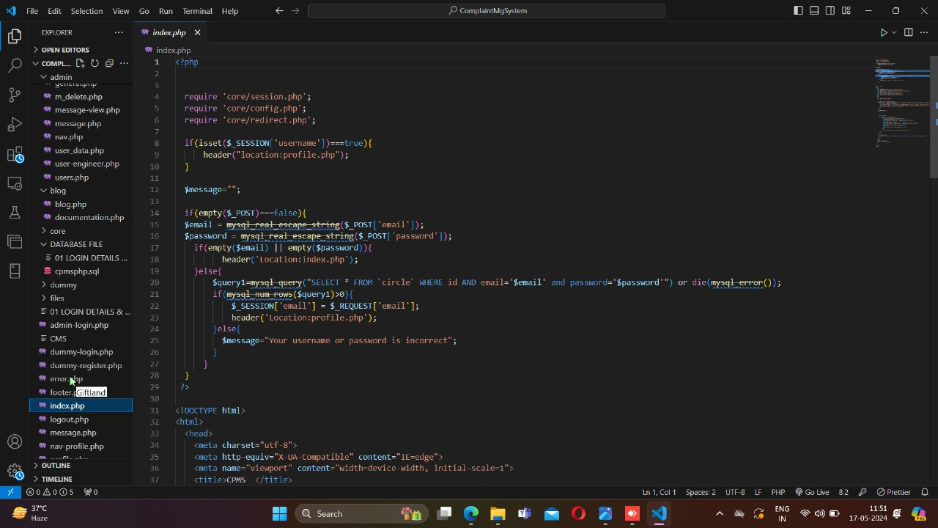

**Figure 7.11 Backend code for User Interface**

* + 1. **Snapshot of Database**

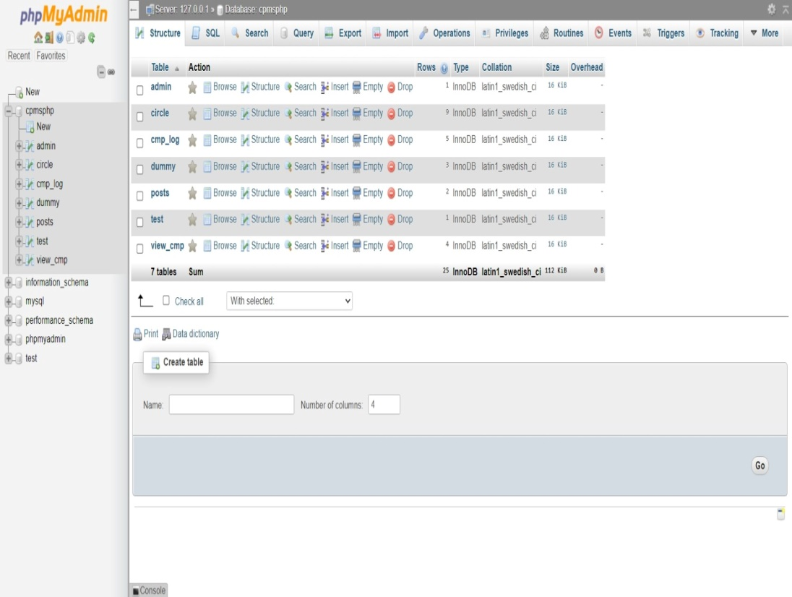

**Figure 7.12 Database All Tables**

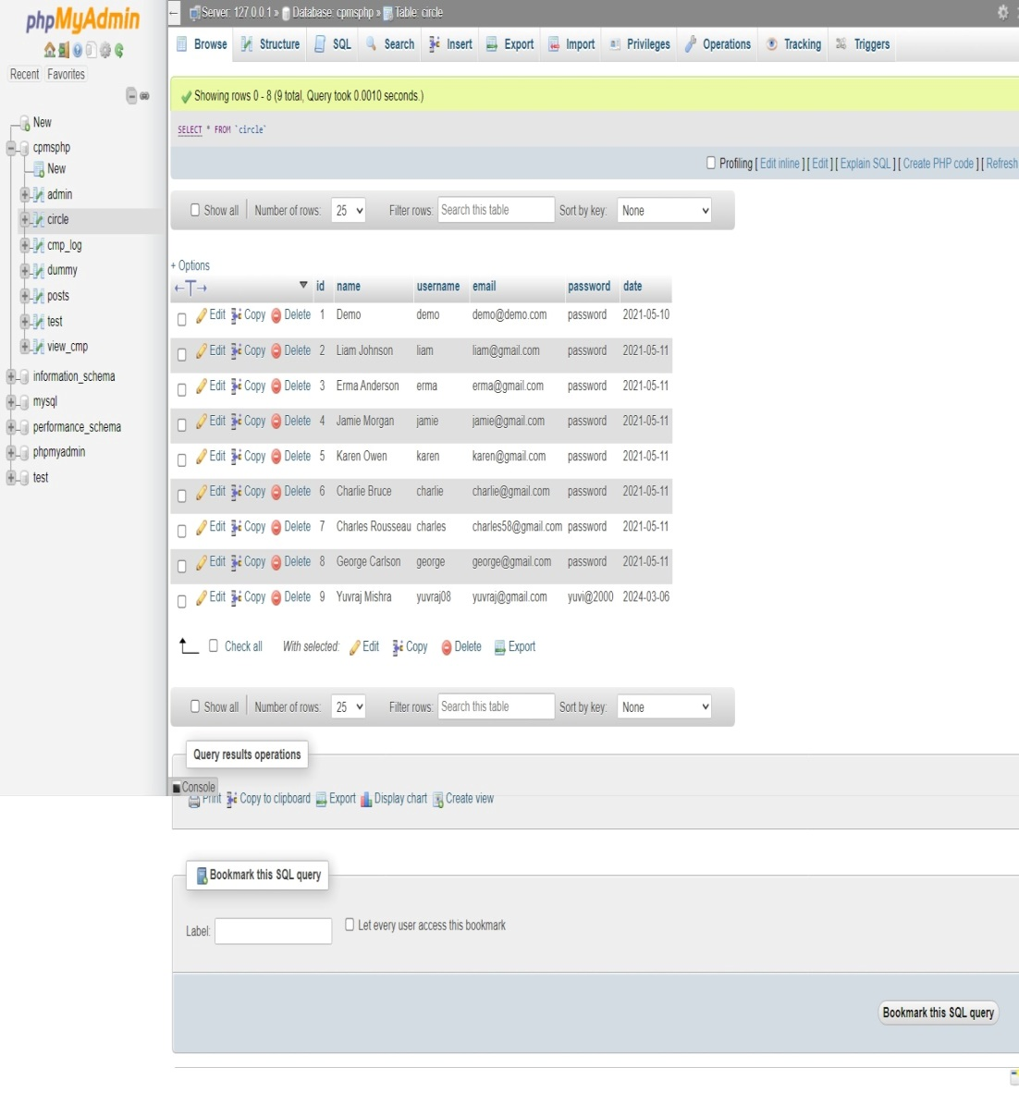

**Figure 7.13 Database User Table**

**CHAPTER 8**

**CONCLUSION AND FUTURE SCOPE**

**Conclusion:**

In conclusion, the online grievance redressal system project marks a significant milestone in addressing the challenges associated with resolving citizen grievances efficiently and transparently. Through the development and implementation of this innovative digital platform, we have democratized access to grievance resolution mechanisms, streamlined processes, and fostered collaboration among stakeholders.

Throughout the project lifecycle, we have adhered to the Agile Software Development Life Cycle (SDLC) model, embracing adaptability, teamwork, and continuous improvement. This approach has enabled us to respond promptly to evolving requirements, deliver incremental value, and ensure that the platform remains responsive to user needs and regulatory changes.

The platform offers a user-friendly interface, robust grievance submission and tracking systems, and features that empower users to engage with the resolution process effectively. By promoting transparency and accountability, the platform has not only enhanced citizen trust but also contributed to improving governance and service delivery. Looking forward, the online grievance redressal system holds immense potential for further expansion and impact. As we continue to iterate and enhance the platform based on user feedback and emerging needs, we aim to extend its reach, enhance its functionality, and deepen its integration within administrative processes.

In closing, we are proud of the achievements attained thus far and remain committed to advancing the platform's mission of promoting

fairness, transparency, and citizen participation in governance. Through collaboration, innovation, and a shared commitment to upholding democratic values, we are confident that the online grievance redressal system will continue to play a pivotal role in fostering a more accountable and responsive society.

**Future Scope:**

Future work for the cloud-based grievance redressal system includes several key areas of focus to further enhance its effectiveness and usability:

1. Mobile Application Development: Developing dedicated mobile applications for online grievance redressal systems can improve accessibility and user experience, allowing individuals to submit and track grievances conveniently from their smartphones.
2. Blockchain Technology: Utilizing blockchain technology for secure and transparent record-keeping of grievance-related data could enhance trust and transparency in the grievance redressal process.
3. Offline Functionality: Develop a robust offline complaint registering system, allowing users to register complaints even in low or no internet connevtivity scenarios, ensuring uninterrupted communication.
4. Enhanced Scalability: As the user base and volume of grievances continue to grow, ensuring the scalability of the system will be crucial. Future efforts should focus on optimizing the system architecture to handle increasing loads without sacrificing performance or responsiveness.
5. Integration with AI and Machine Learning: Leveraging artificial intelligence (AI) and machine learning (ML) algorithms can significantly improve the efficiency and accuracy of grievance resolution processes. Future work should explore integrating AI-driven technologies for automated grievance categorization, sentiment analysis, and predictive analytics to streamline decision-making and prioritize responses.
6. Gamification Elements: Incorporating gamification elements such as badges, rewards, or leaderboards can incentivize user participation and promote active engagement with the grievance redressal system. Users can earn rewards or recognition for submitting high-quality grievances, providing constructive feedback, or actively participating in community discussions, fostering a sense of ownership and motivation.
7. Automated Notifications and Reminders: Implementing automated notification and reminder features can enhance communication between users and administrators throughout the grievance resolution process. Users can receive real-time updates on the status of their grievances, upcoming deadlines, or required actions, reducing ambiguity and ensuring timely responses.
8. Social Media Integration: Integrating social media platforms into the grievance redressal system can expand its reach and enhance user engagement. Users can submit grievances or provide feedback directly through social media channels, while administrators can monitor and respond to inquiries in real-time, increasing responsiveness and public visibility.

**REFERENCES**

[1] Rana, Nripendra P., et al. "Adoption of online public grievance redressal system in India: Toward developing a unified view." Computers in Human Behavior 59 (2016): 265-282.

[2] Rana, Nripendra, Michael Williams, and Yogesh Dwivedi. "Examining factors affecting adoption of online public grievance redressal system: A case of India." (2013).

[3] Chander, Subhash, and Ashwani Kush. "Assessing grievances redressing mechanism in India." International Journal of Computer Applications 52.5 (2012).

[4] Rana, Nripendra P., Yogesh K. Dwivedi, and Michael D. Williams. "Examining the factors affecting intention to use of, and user satisfaction with online public grievance redressal system (OPGRS) in India." Grand Successes and Failures in IT. Public and Private Sectors: IFIP WG 8.6 International Working Conference on Transfer and Diffusion of IT, TDIT 2013, Bangalore, India, June 27-29, 2013. Proceedings. Springer Berlin Heidelberg, 2013.

[5] Chowdhury, Md Shahidul Islam. "Strengthening Grievance Redress System: A Case of Narsingdi District Administration." angladesh ournal of ublic dministration 31.1 (2023): 23-46.

[6] Shettigar, Rakshitha, et al. "Blockchain-Based Grievance Management System." Evolution in Computational Intelligence: Frontiers in Intelligent Computing: Theory and Applications (FICTA 2020), Volume 1. Springer Singapore, 2021.

[7] Prajapat, Shaligram, Vaibhav Sabharwal, and Varun Wadhwani. "A prototype for grievance redressal system." Proceedings of International Conference on Recent Advancement on Computer and Communication: ICRAC 2017. Springer Singapore, 2018.

[8] Shahi, Abhinav. "Grievance Redressal in India during Pandemic and the Way Forward." ASCI Journal of Management 51.1 (2022).

[9] Aravindhan, K., et al. "Web Portal for Effective Student Grievance Support System." *2020 6th* International Conference on Advanced Computing and Communication Systems *(*ICACCS*)*. IEEE, 2020.

[10] Rana, Nripendra P., et al. "An extended DeLone and McLean's information system model for examining success of online public grievance redressal system in Indian context." International Journal of Indian Culture and Business Management 10.3 (2015): 267-290.

[11] Kumar, Anil, et al. "Does e‐service quality of online grievance redress portals lead to satisfaction? An outlook from the perspectives of I ndian youth." Journal of Public Affairs 23.1 (2023): e2822.

[12] Project Github Link: <https://github.com/YuvrajNarayanMishra/GrievanceRedressalSystem.git>

[13] Project Documents Link: <https://drive.google.com/drive/folders/1u67hXZYUdedFaAuPlBEUq2Uj4ipdtTTf>

**RESEARCH PAPER ACCEPTANCE PROOF**

**Title of Paper: “**Revolutionizing Grievance Redressal System: An Adaptive Framework with a Proposed Architecture”

**Journal Name:** International Research Journal of Modernization in Engineering Technology & Science (IRJMETS)

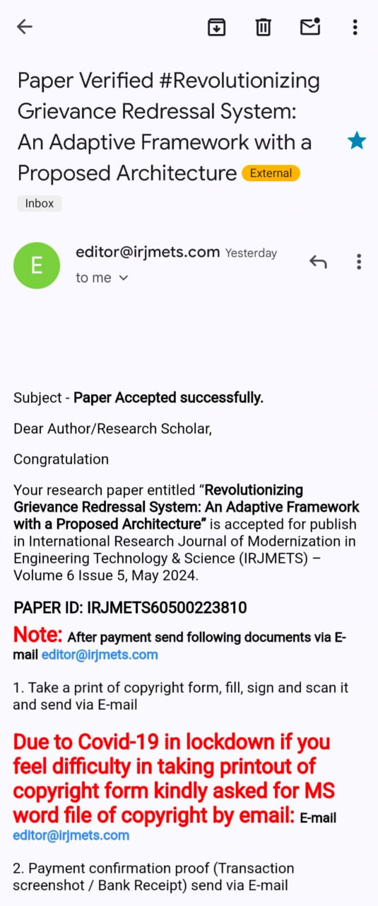

**Patent Details**

**Through KIET:**

